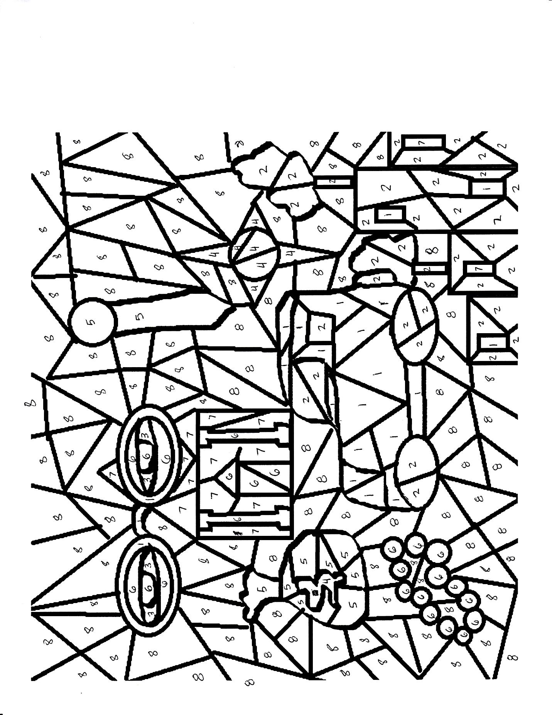

**Determine the color the below clues symbolize, and then fill in the drawing with the corresponding color to each number.**

**Color Bank: Blue White Yellow Gray Gold Red Green**

1. **Fake Gold, Desire & Failure, Falsity, Dishonesty**
2. **Lifelessness, Bareness, Decay & Degradation**
3. **Illusions, Unreality, Transformation**
4. **Life, The Future, New Money, Hope**
5. **Old Money, Wealth, Status**
6. **Purity, Innocence, Femininity, Corruption**
7. **Passion, Love, Sin**
8. **“Freebee”- Purple**